Checklist

Q1. Does running your code against the 2 sample cases shown in the assignment description produce a similar output? (Yes/No) (Minor differences in duration and distance are ok)

**Yes**

Q2. Does your code display an appropriate error message when the user either leaves the text field blank or enters only 1 location (Yes/No) - Paste a screenshot

**Yes**

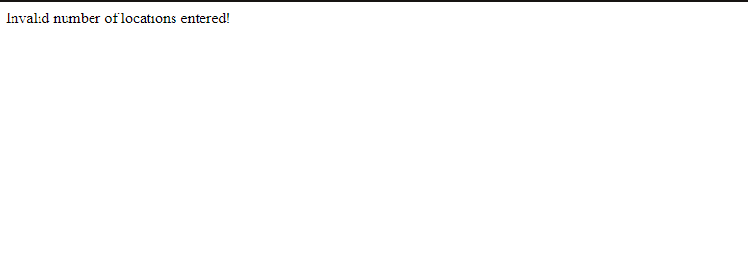

Q3.Does your code run work when you enter ONLY 2 locations on your trip (e.g., Las Vegas Nevada, Phoenix AZ ) (Yes/No) - If yes, paste a screenshot of your browser for the example query

Estimated Output

Total Distance: 301.55 miles

Total Time: 5 hours 5 minutes 1 second

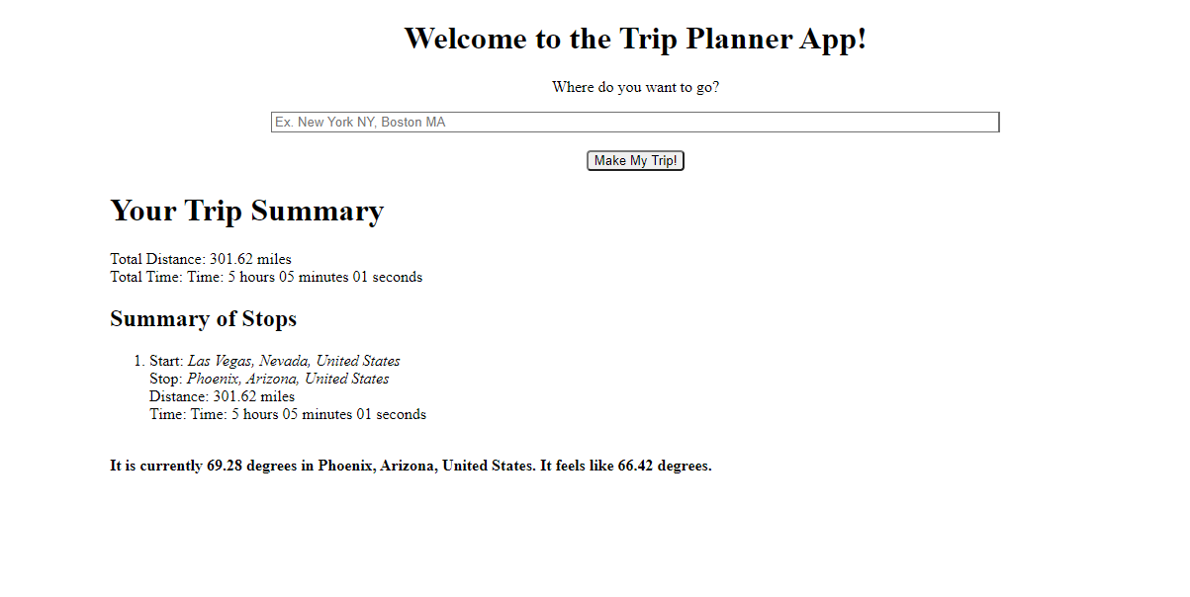**Yes**

Q4. Does your code work if the start and end locations are the same (e.g., Universal Studios FL, Disney World FL, Busch Gardens Tampa, Universal Studios FL) (Yes/ No) - If yes, paste a screenshot of your browser for the example query?

Estimated Output

Total Distance: 157.97 miles

Total Time: 3 hours 25 minutes 52 seconds

**Yes**

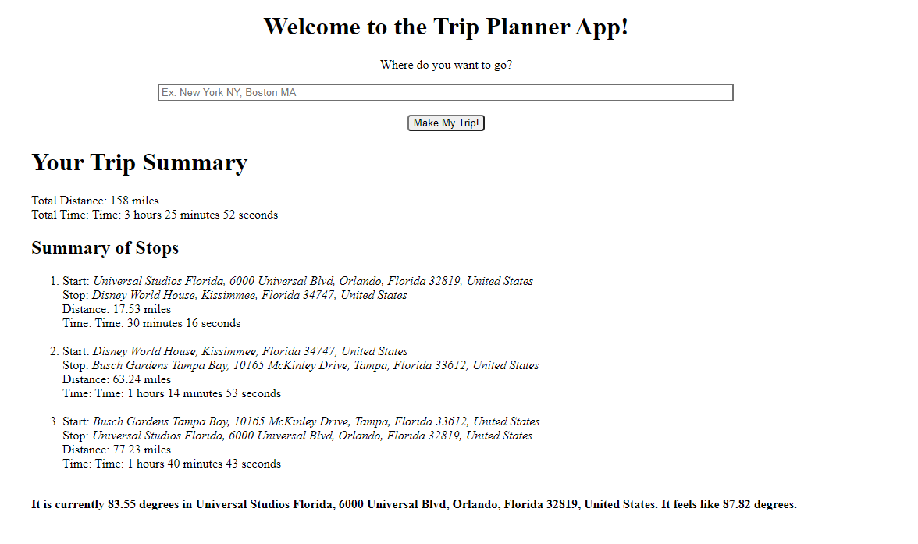

Q5. Did you attempt the extra credit? (Yes/No)

**No**